Data structures

Multiple arguments

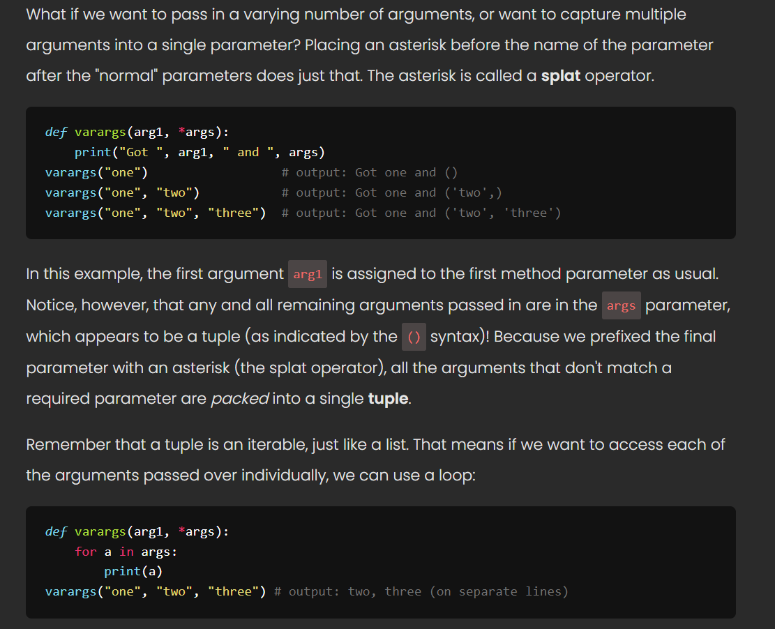

Data Structures

Data structures are data types that allow us to store and manage multiple values. Where **primitive** data types are single values, like numbers or strings, **data structures** allow us to have collections of values in a single variable. Arrays, lists, and dictionaries are each examples of data structures.

We have been *using* data structures for a few weeks, but now that we know how to construct classes with methods, we're going to take a deeper dive into how these work under the hood! We're going to start by looking specifically at one data structure known as a **singly linked list**. The list is simply a **class** that has **methods**; just as Python's list class has methods like append(val) and pop(), we're going to write a class with the same functionality.

Helpful links

<https://web.stanford.edu/class/cs101/bits-bytes.html>

<https://digital-photography-school.com/16-bit-vs-32-bit-vs-64-bit-what-does-it-all-mean/>

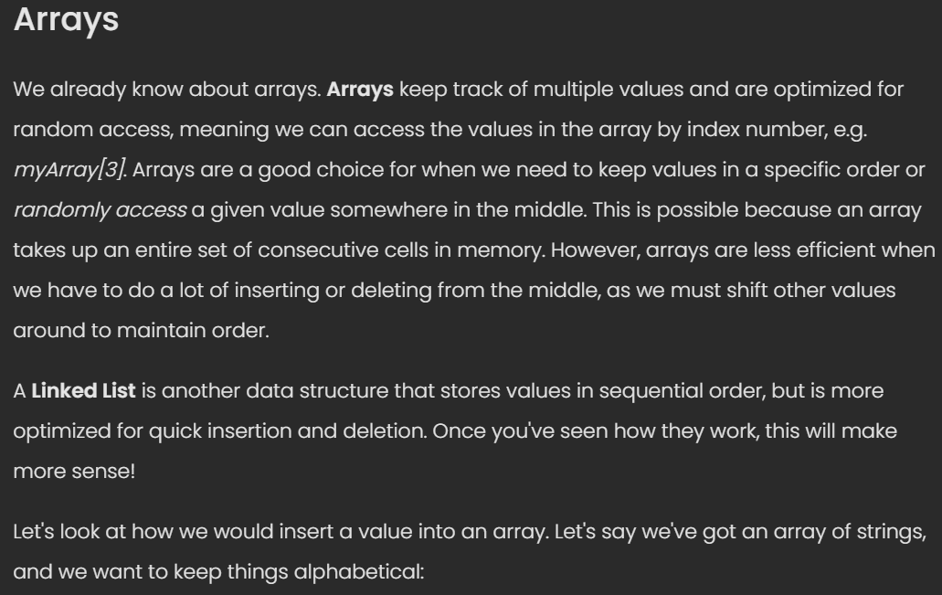

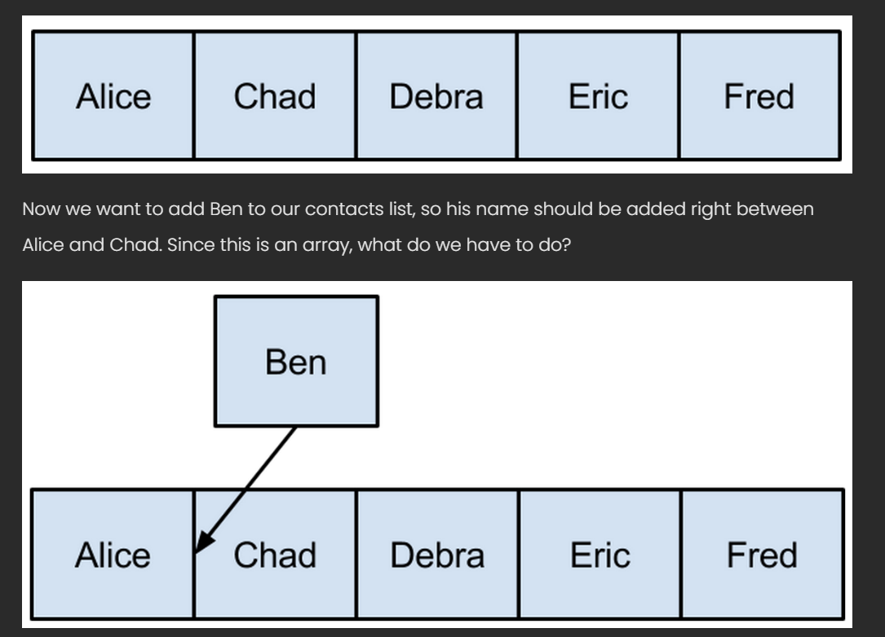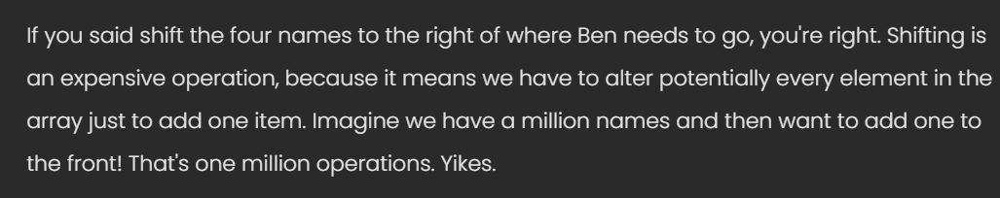

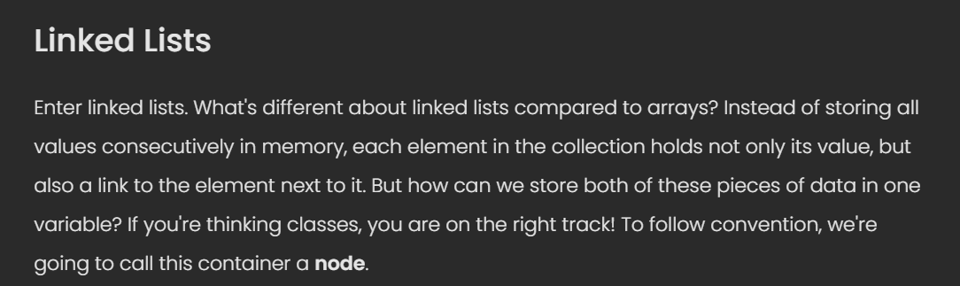

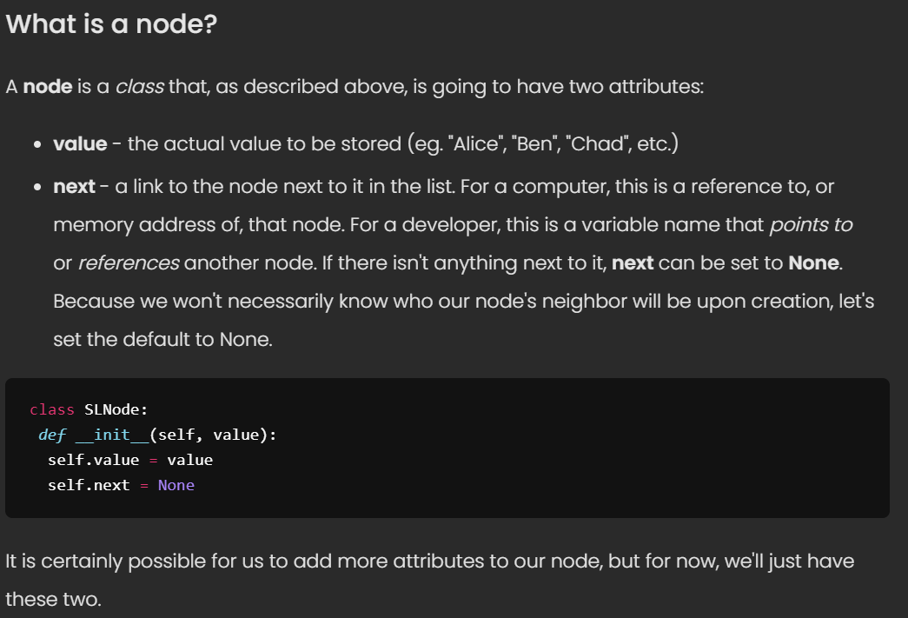

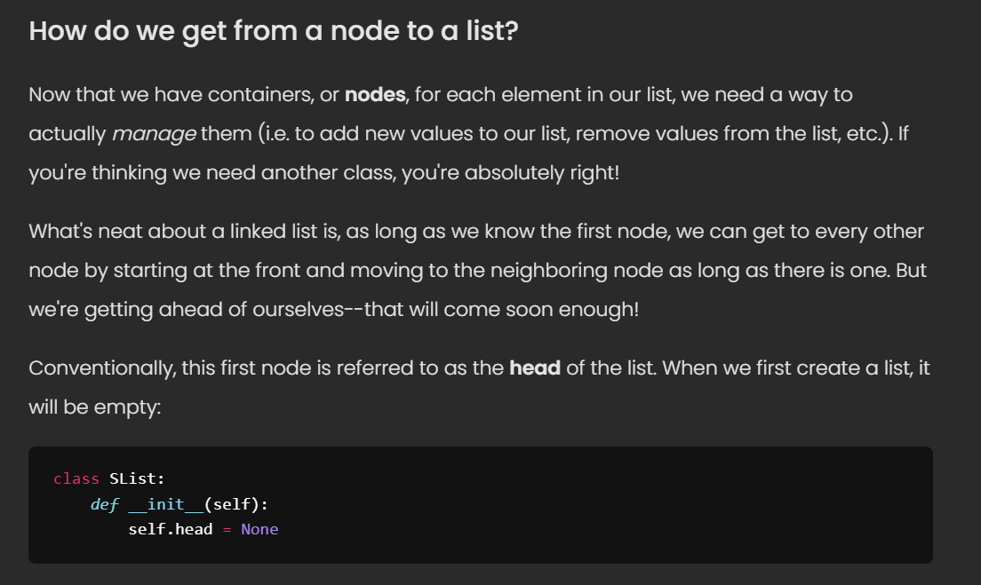

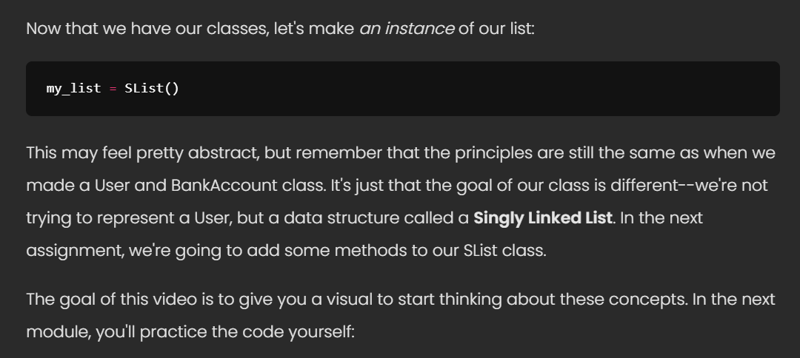

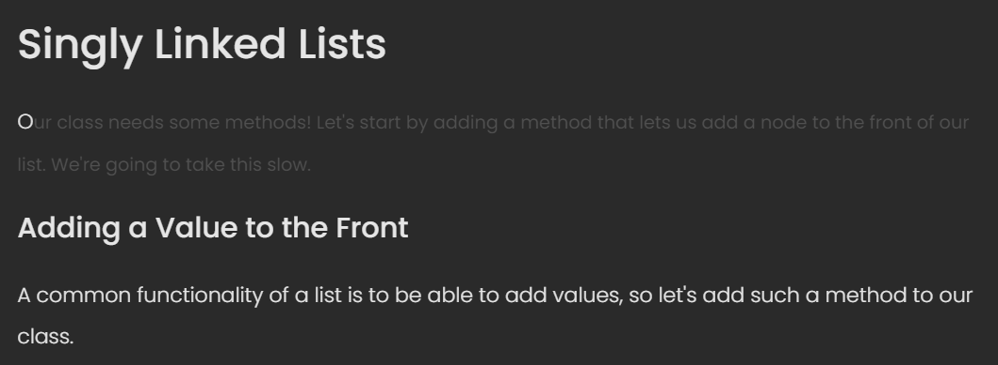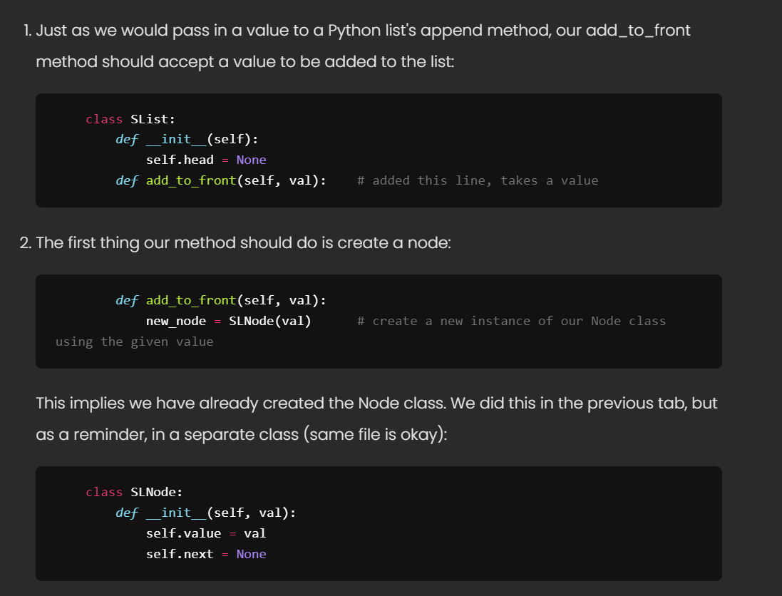

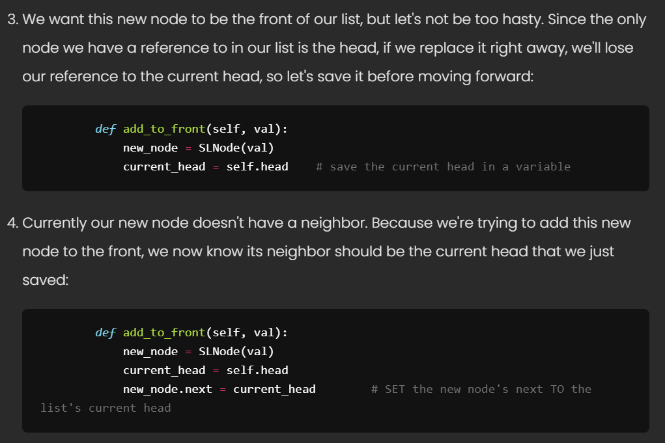

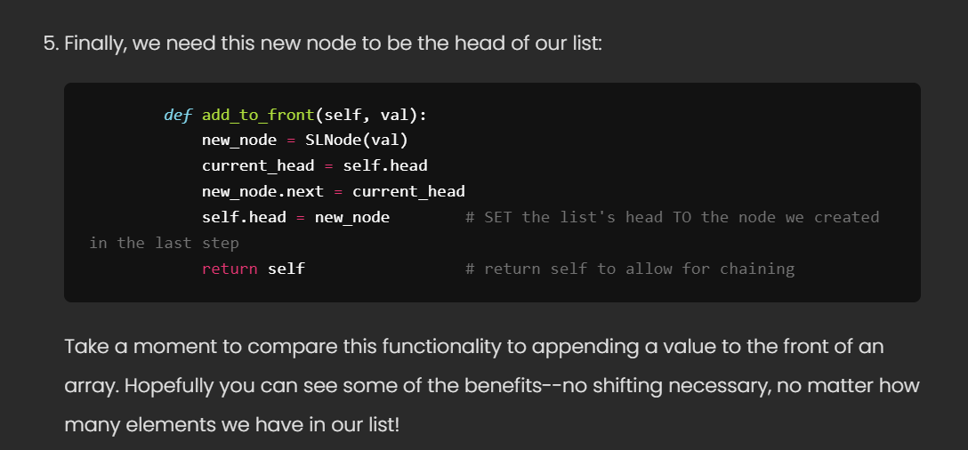

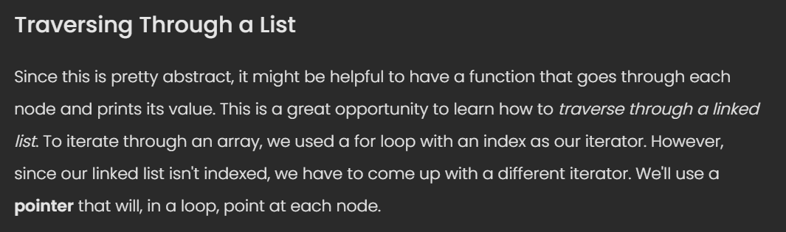

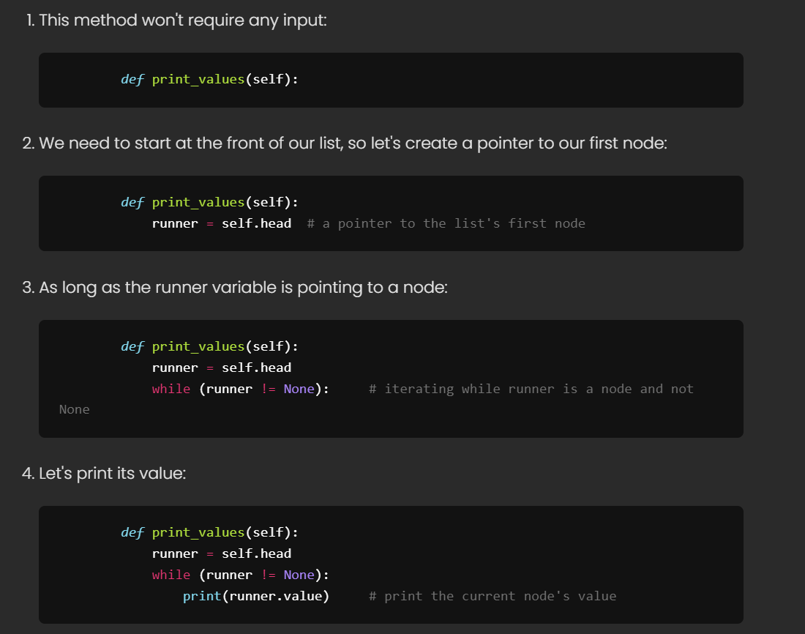

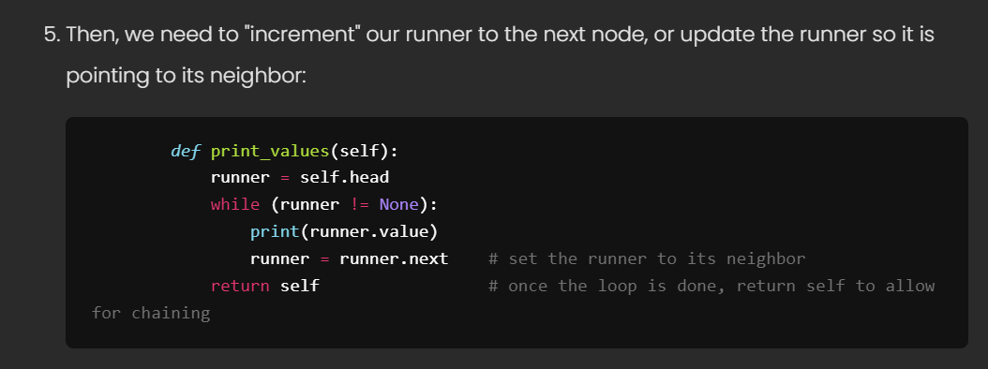

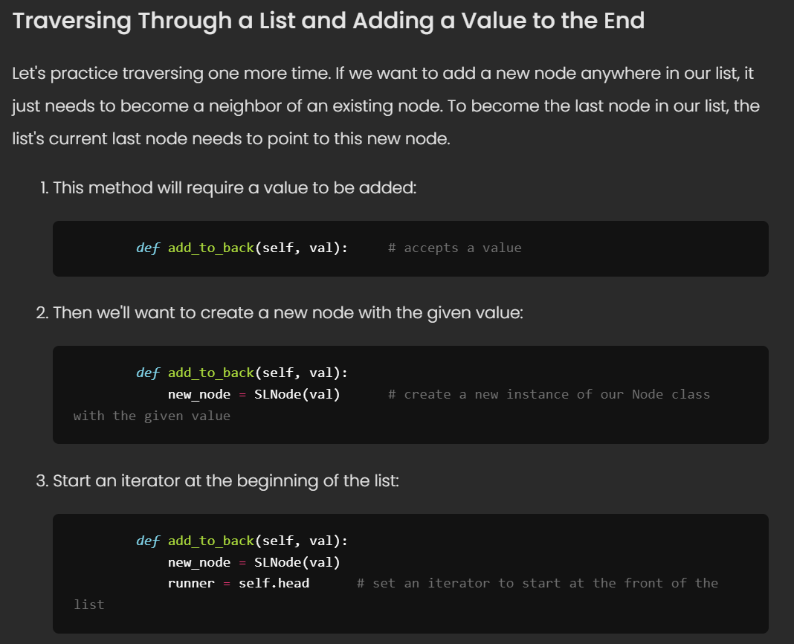

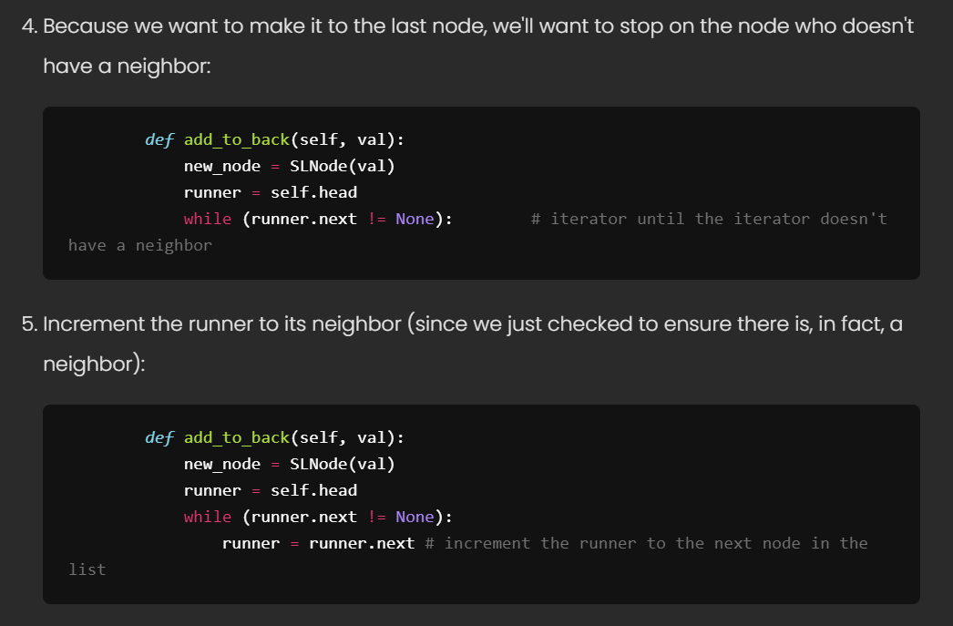

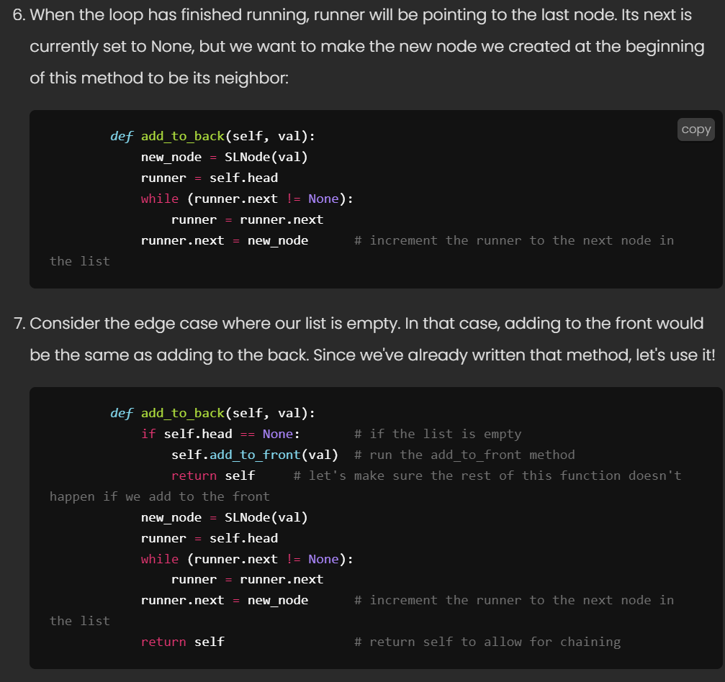



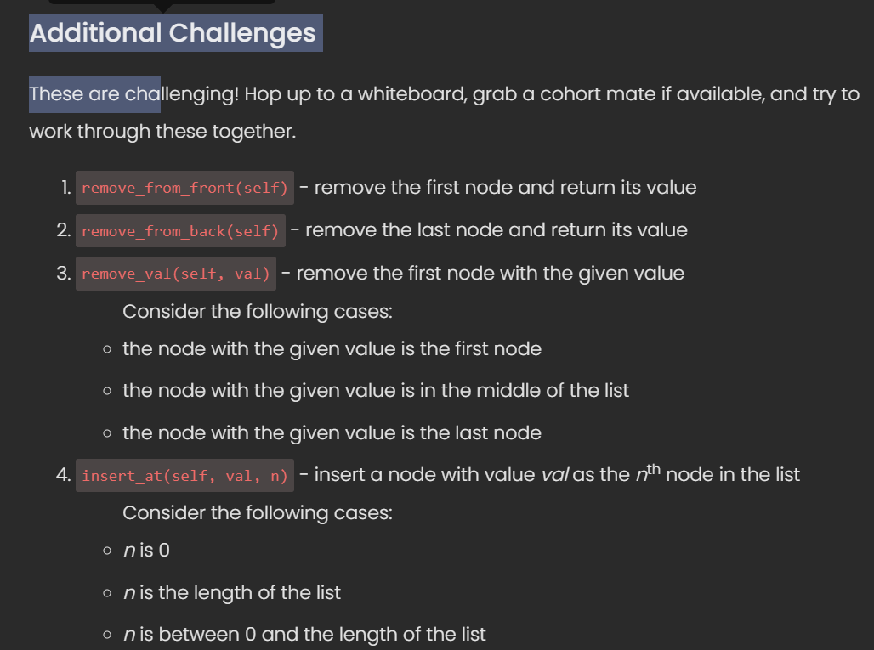

Helpful Links

Hash Tables

<https://en.wikipedia.org/wiki/Hash_table>

Binary Search Trees

<https://en.wikipedia.org/wiki/Binary_search_tree>

Stacks & Queues

[https://www.cs.cmu.edu/~adamchik/15-121/lectures/Stacks%20and%20Queues/](https://www.cs.cmu.edu/~adamchik/15-121/lectures/Stacks%20and%20Queues/Stacks%20and%20Queues.html)



<http://en.wikipedia.org/wiki/Doubly_linked_list> is a great start.



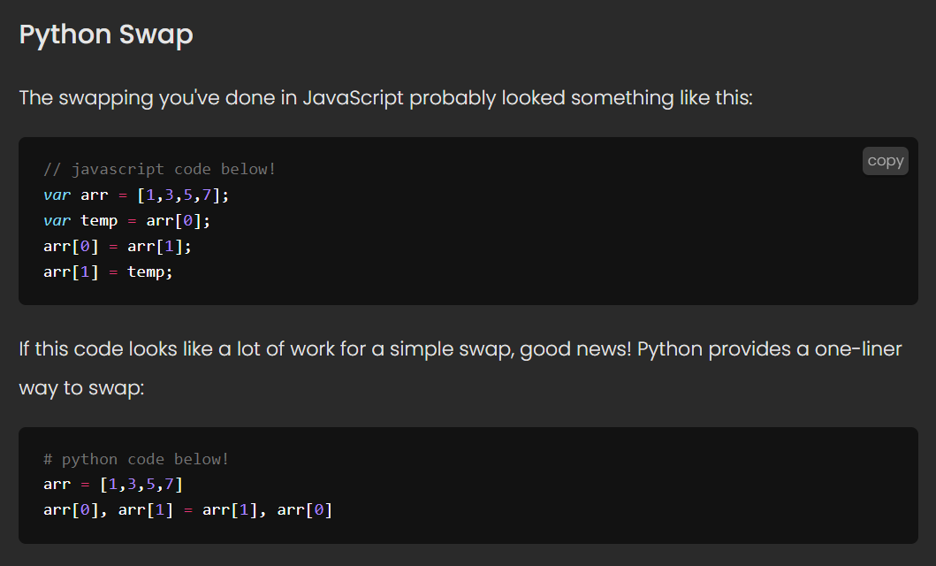





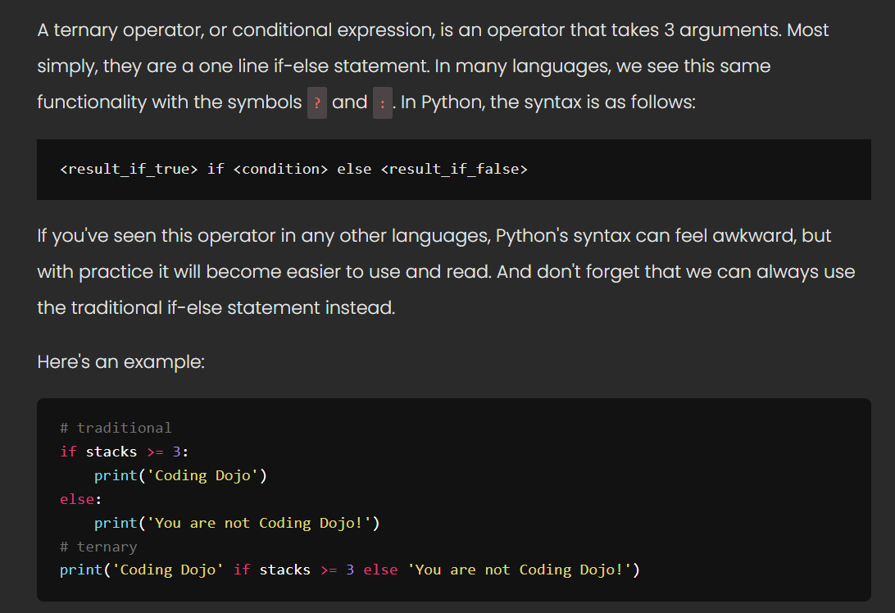

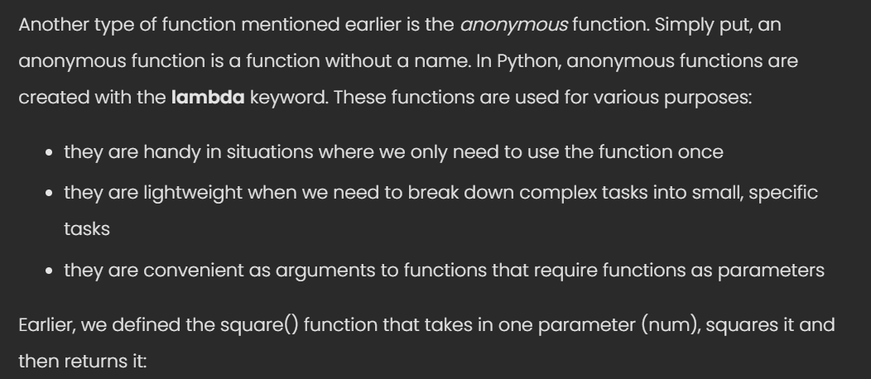

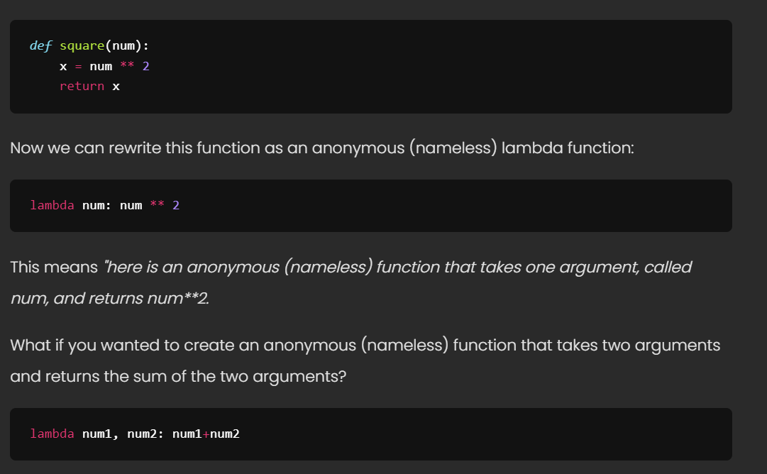

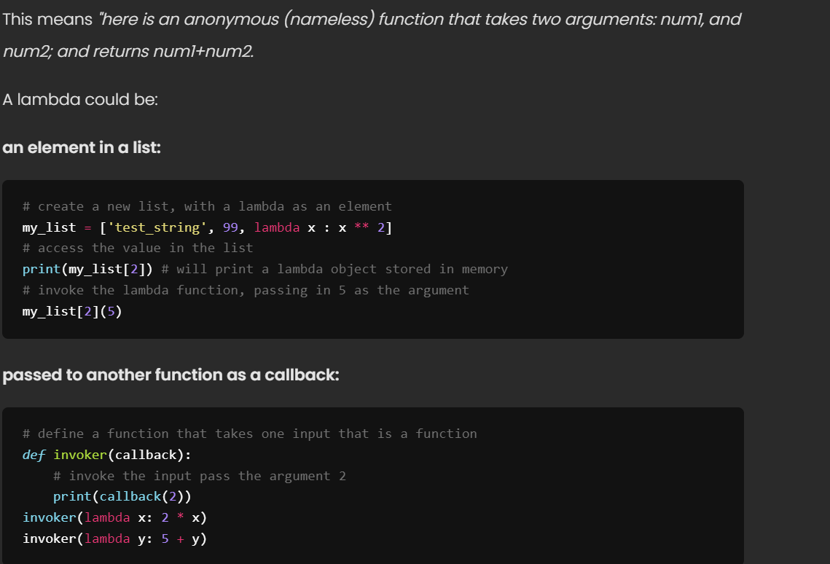

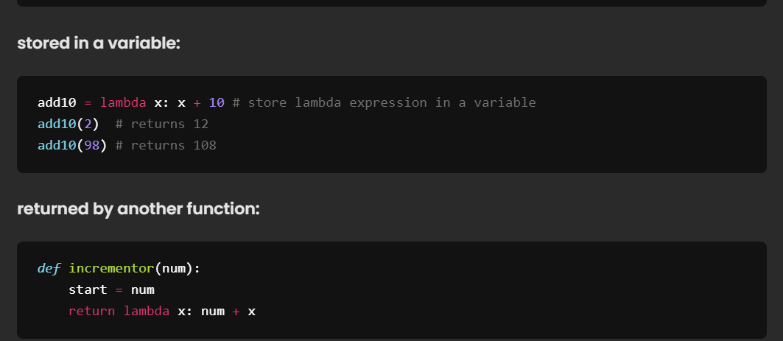

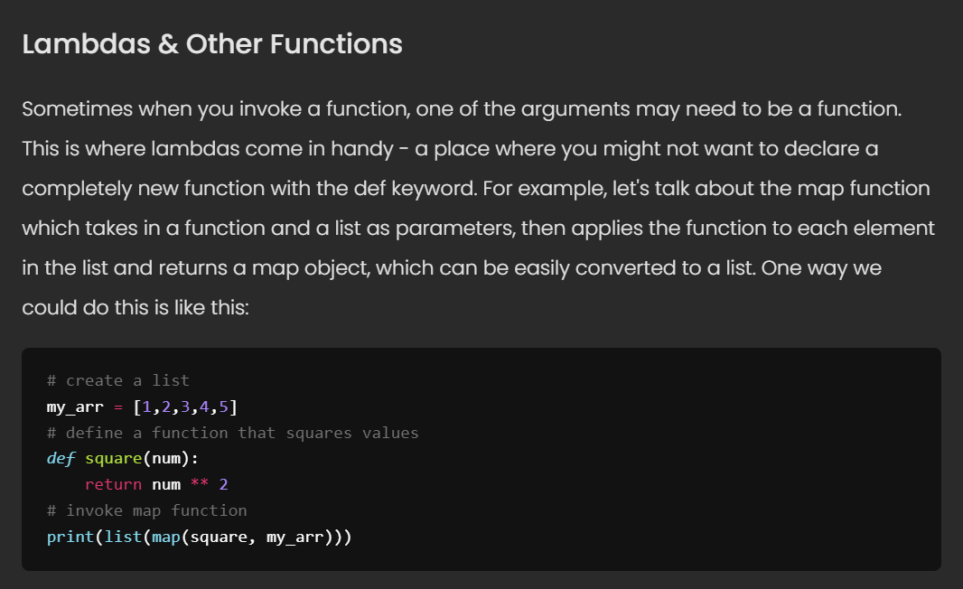

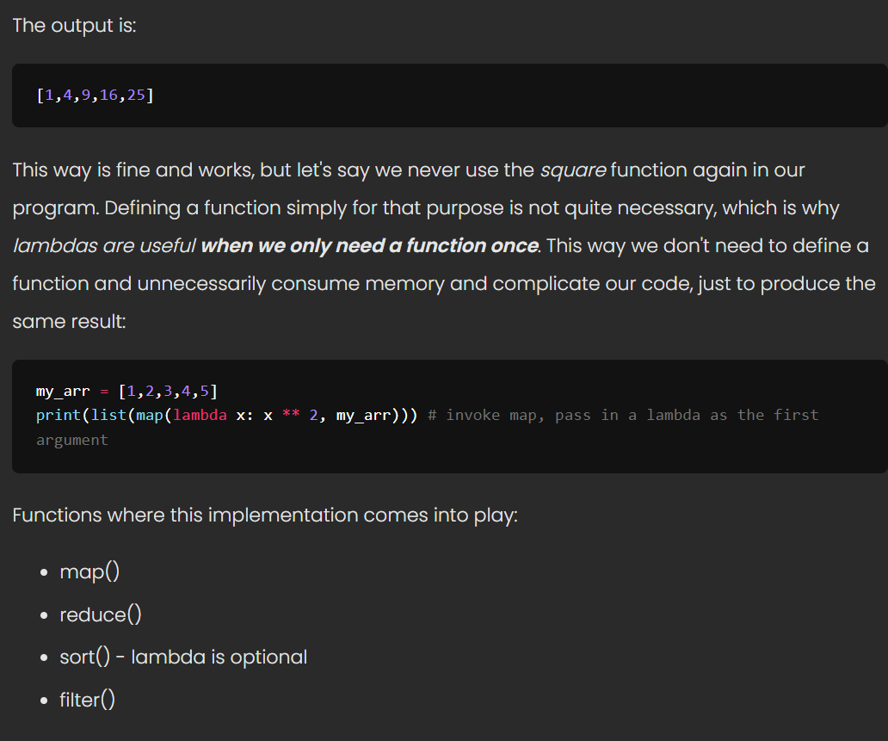

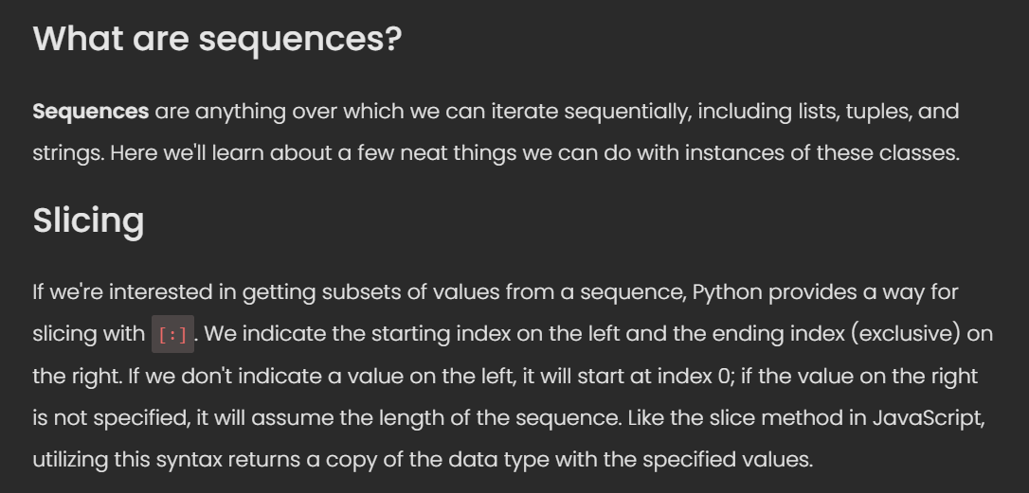

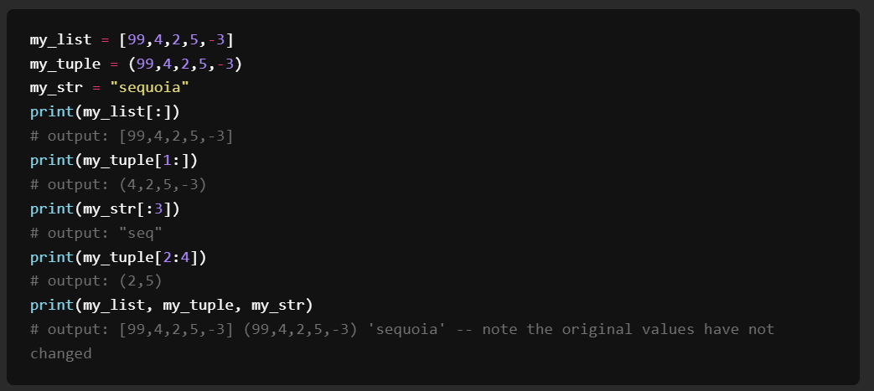

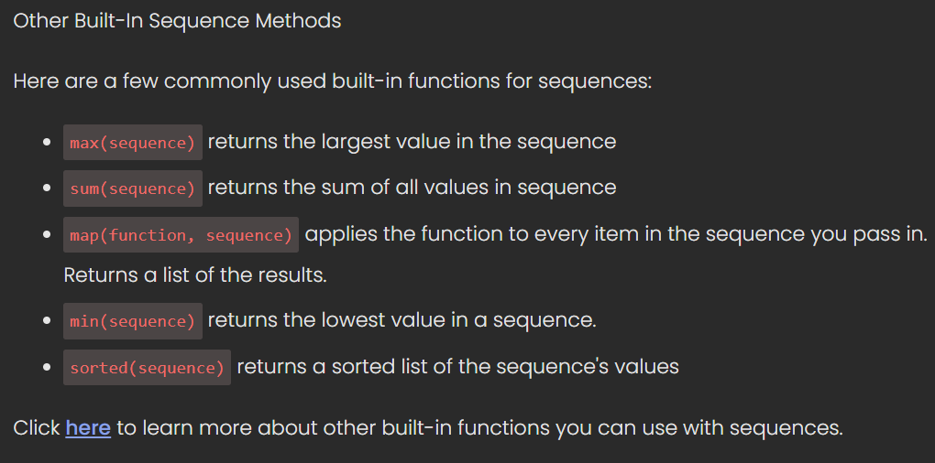

<http://www.linuxtopia.org/online_books/programming_books/python_programming/python_ch14s07.html>



* <https://realpython.com/face-recognition-with-python/>
* <https://realpython.com/face-detection-in-python-using-a-webcam/>

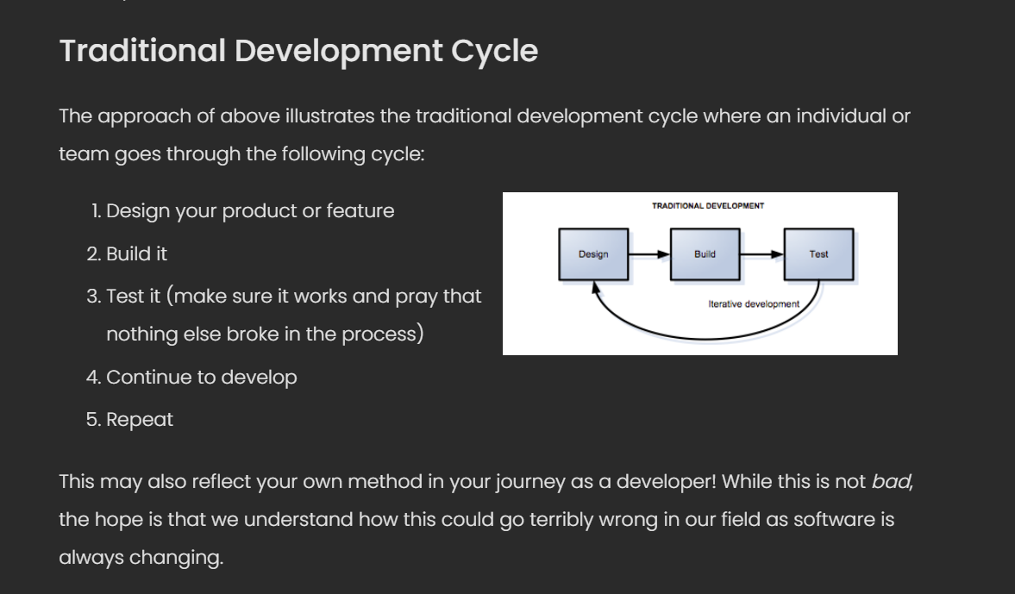

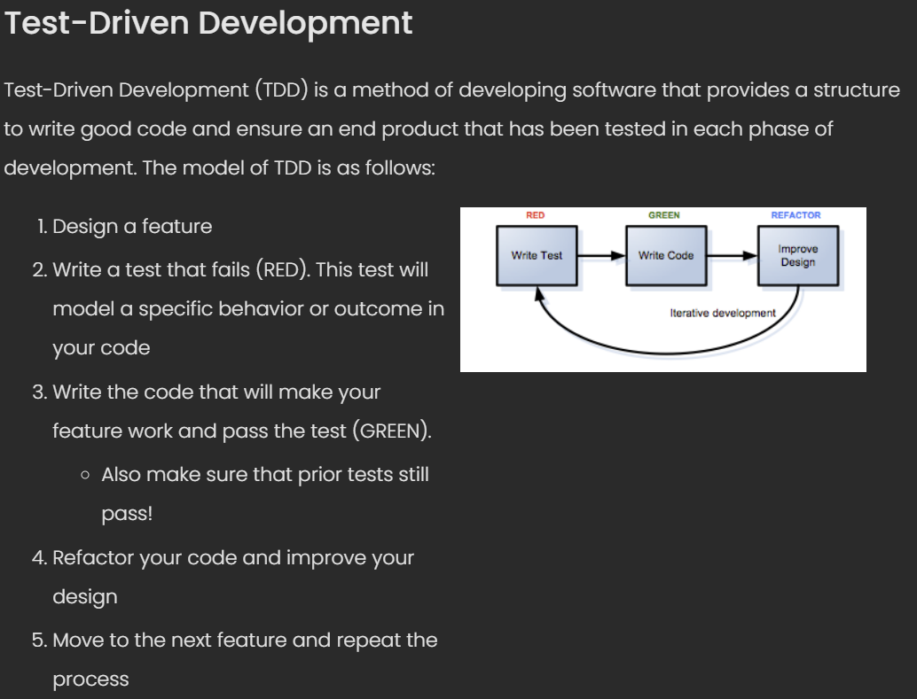

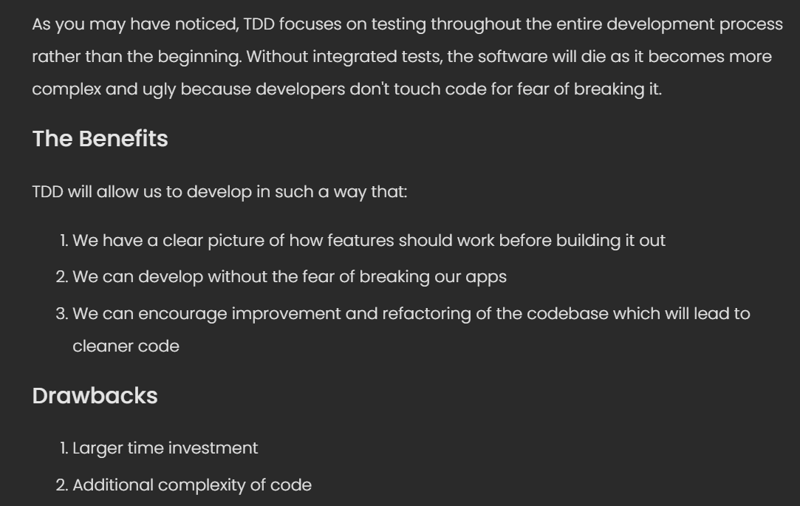

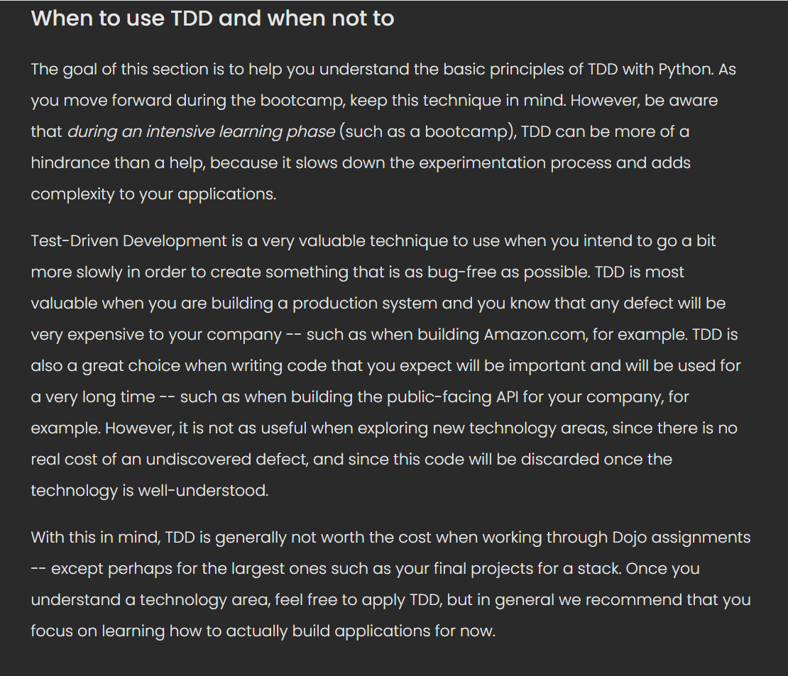



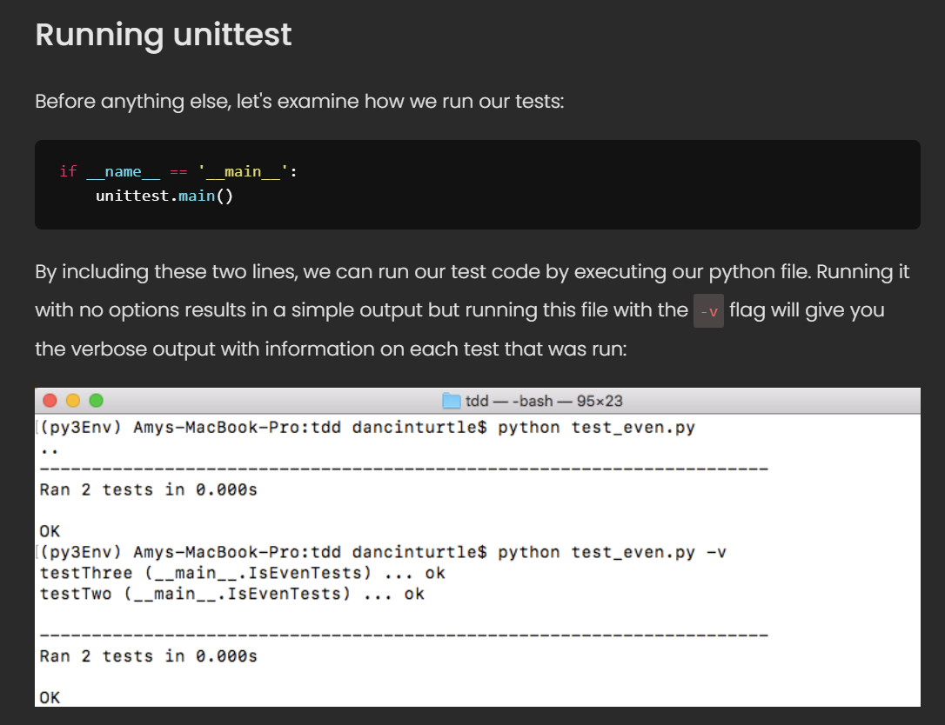

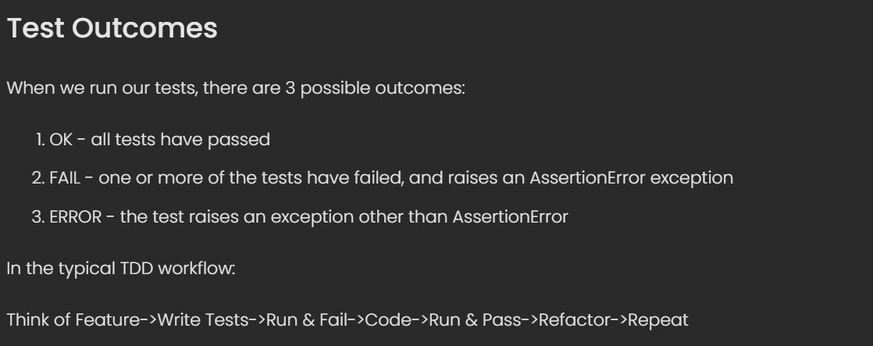

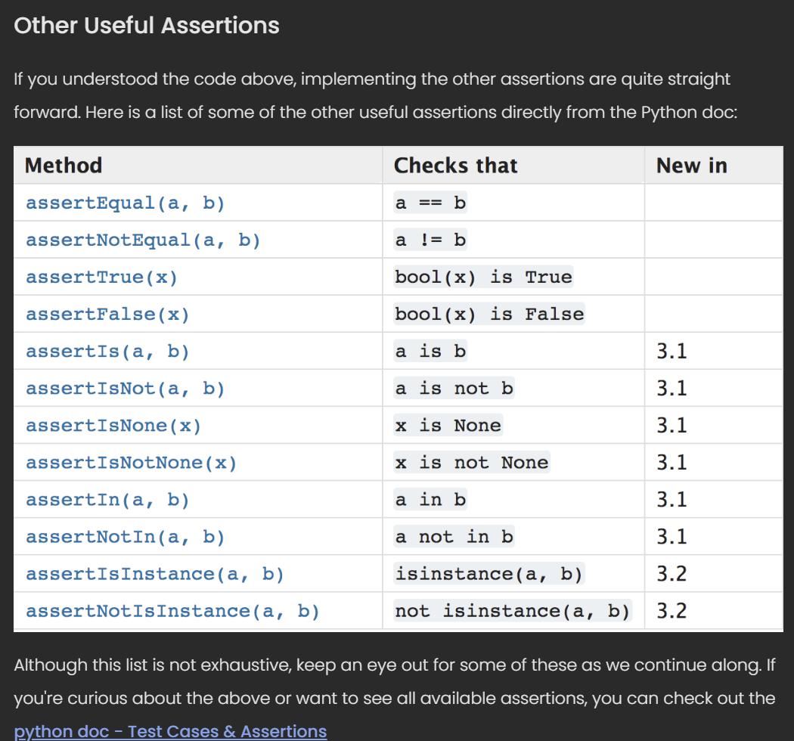

https://docs.python.org/3.6/library/unittest.html#test-cases